INSTRUCTIONS

MULTIPLE CHOICE Select the best answer choice. Write your answer choices below:

- Increasing: _(-3,-2)_____
Decreasing: _(1,3)_______
Constant: ___(-1,1)______

- __B___

- __D___

- __A. The equation of the line is f(x) = x-1. fof(x) is calculated to be fof(x)= x – 2, whose graph is A.___

- __C___

(1) Determine the intervals on which the function is
Increasing: ____________________
Decreasing: ____________________
Constant: ____________________
$$y$$
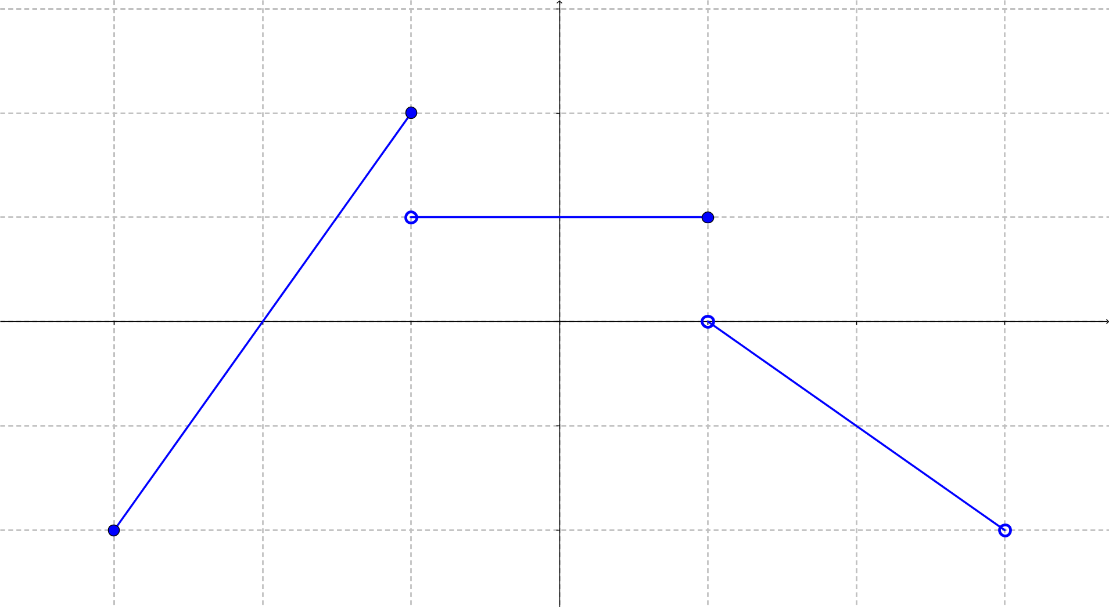
$$x$$
$$\left(3, -2\right)$$
$$\left(1, 0\right)$$
$$\left(1, 1\right)$$
$$\left(-1, 1\right)$$
$$\left(-1, 2\right)$$
$$\left(-3, -2\right)$$
Solution: (Explanation)

(2) The U.S. annual per-capita consumption of coffee was 33.4 gal in 1970. By 2007, this amount had decreased to 24.6 gal. (Source: Economic Research Service, U.S. Department of Agriculture). What is the average rate of change in coffee consumption per capita from 1970 to 2007? Round your answer to four places.

$$\left(A\right) -4.2045 \left(B\right) -0.2378 \left(C\right) 0.2378 \left(D\right) 4.2045 \left(E\right) none of the above$$

Solution:

(3) The graph of $f\left(x\right)$ is shown below:
$$y$$
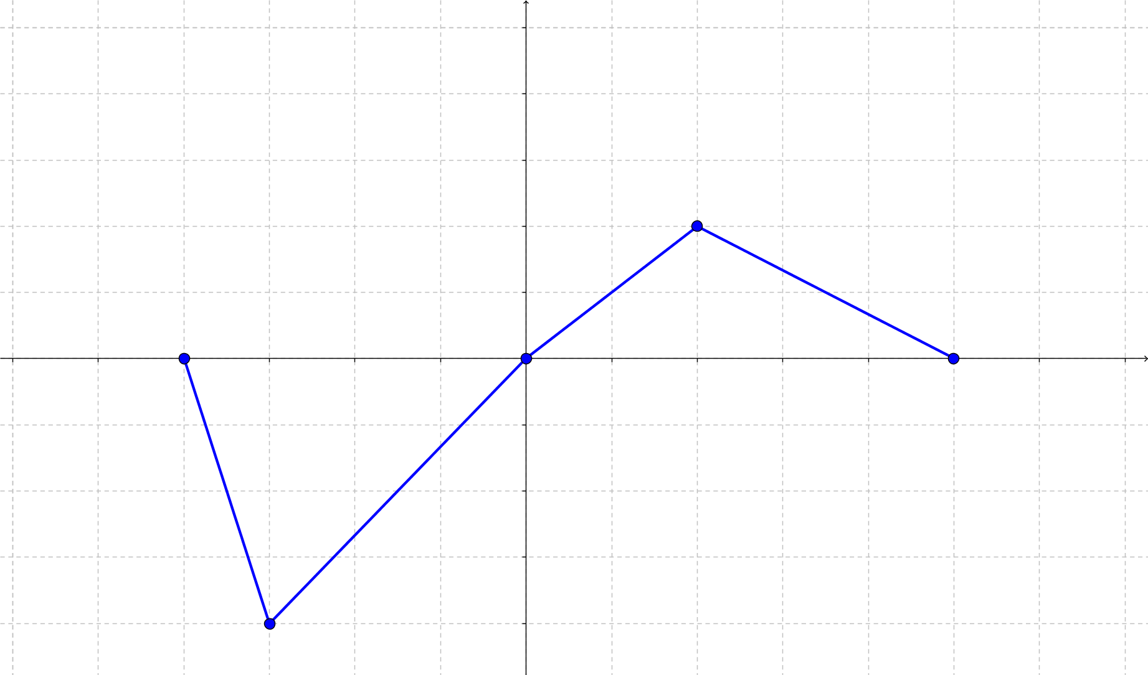
$$-4$$
$$-3$$
$$-2$$
$$-1$$
$$-5$$
$$-4$$
$$-3$$
$$-2$$
$$-1$$
$$4$$
$$3$$
$$2$$
$$1$$
$$y=f\left(x\right)$$
$$x$$
$$1$$
$$2$$
$$3$$
$$4$$
$$5$$
The graph of $g\left(x\right)=-\frac{1}{2}f\left(x\right)+1$ is which of the following?
$(A)$ $\left(B\right)$
$$y$$
$$y$$
$$x$$
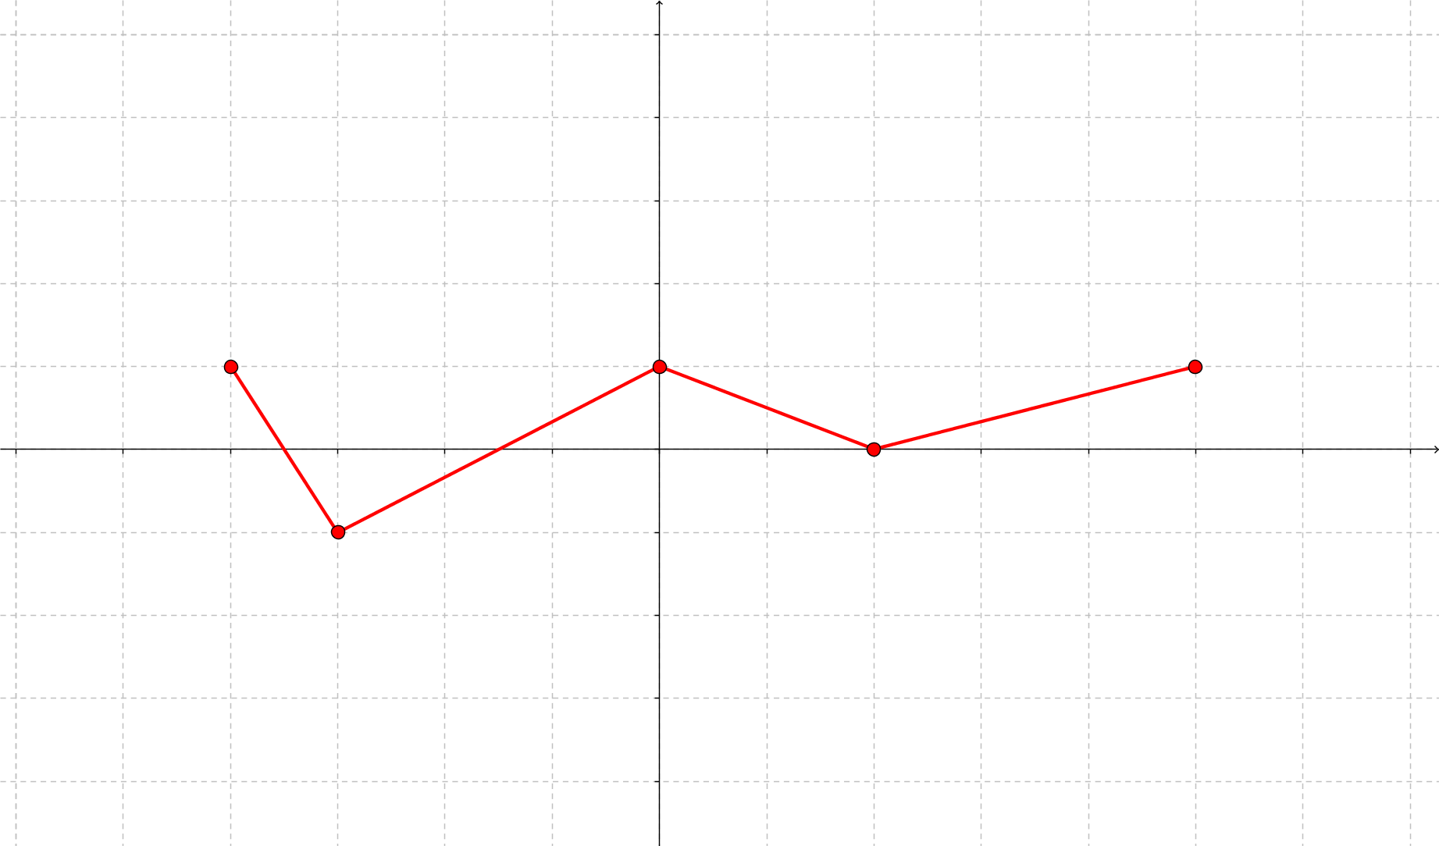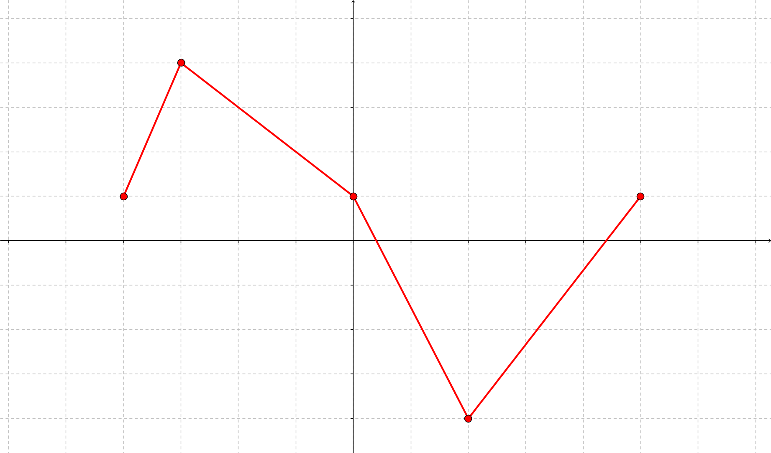
$$x$$
-3
-2
-1
-4
-4
-3
-2
-1
2
4
3
4
2
-1
1
1
3
5
-1
1
5
4
3
2
3
2
1
$\left(C\right)$ $\left(D\right)$
$$x$$
$$y$$
$$y$$
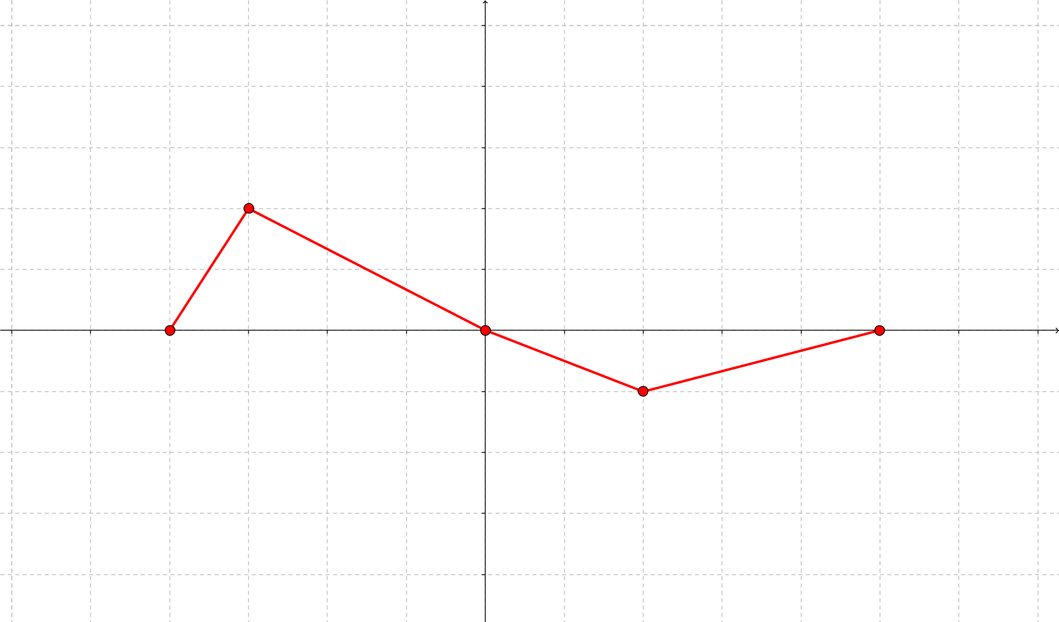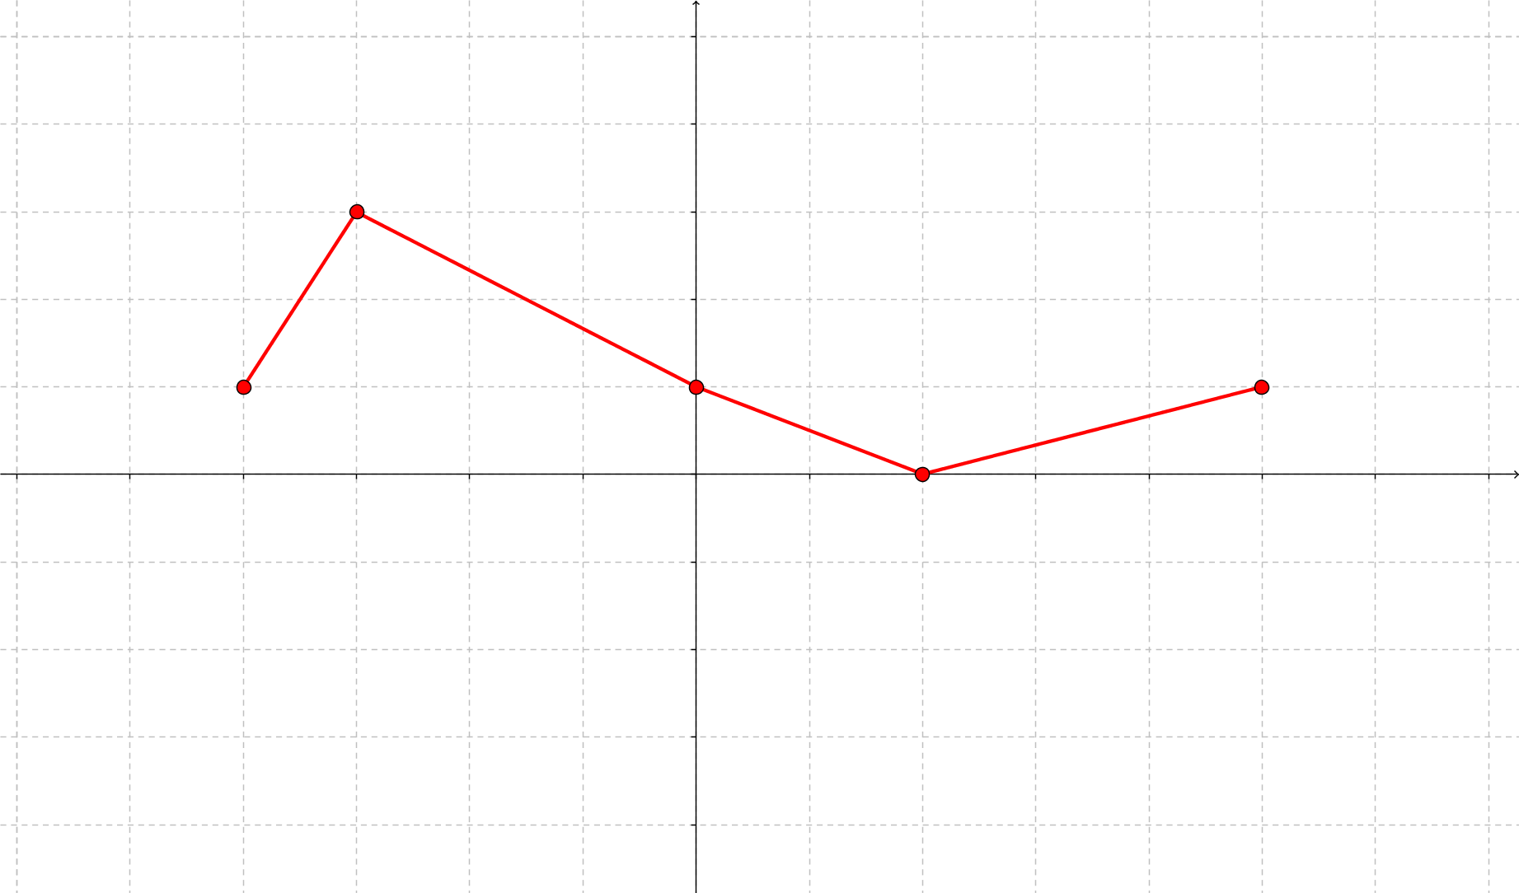
1
4
3
1
5
2
-1
3
2
5
4
$$x$$
2
-3
-2
-1
3
-4
1
-1
1
2
-2
-3
-1
3
-4
$$\left(E\right) none of the above$$
Solution:

(4) Use the graph of $f\left(x\right)$ to determine which of the following is the graph of
$g\left(x\right)= \left(f o f\right)\left(x\right)$. Explain your reasoning.
$$y$$
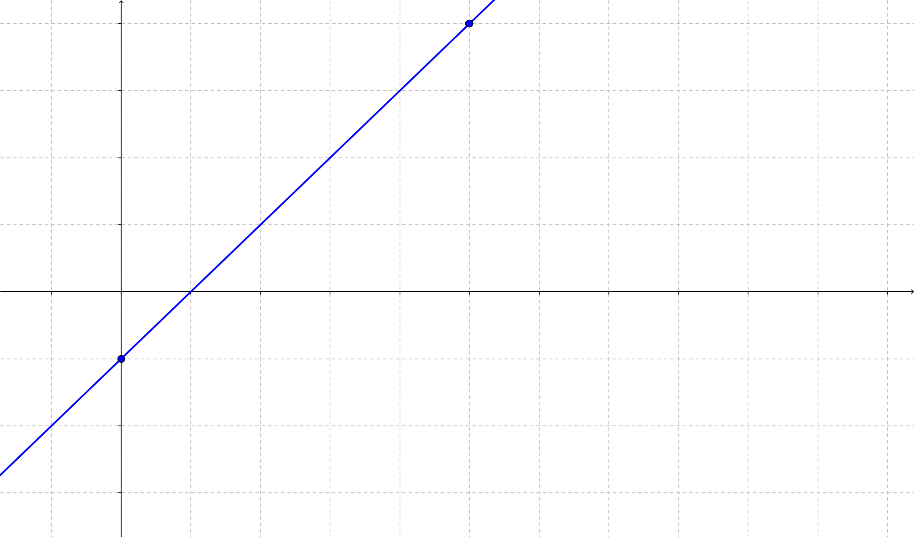
$$\left(0, -1\right)$$
$$x$$
$$f\left(x\right)$$
$$\left(5, 4\right)$$
$\left(A\right)$ $\left(B\right)$
$$y$$
$$g\left(x\right)$$
$$g\left(x\right)$$
$$y$$
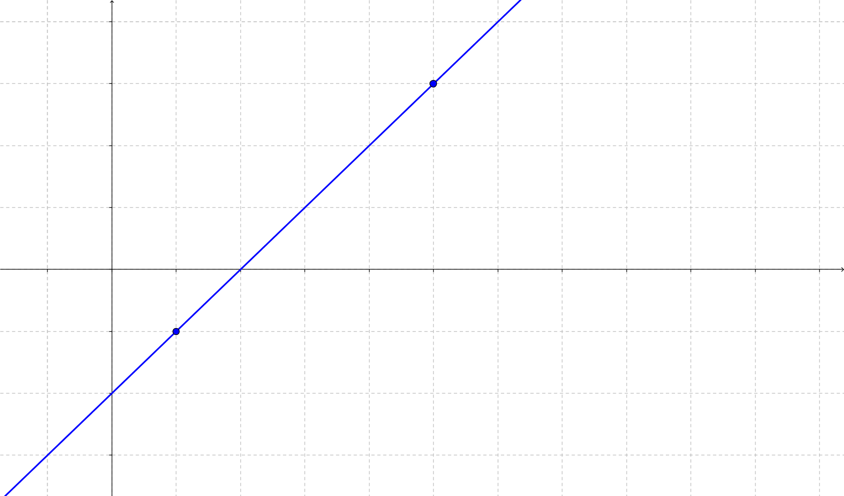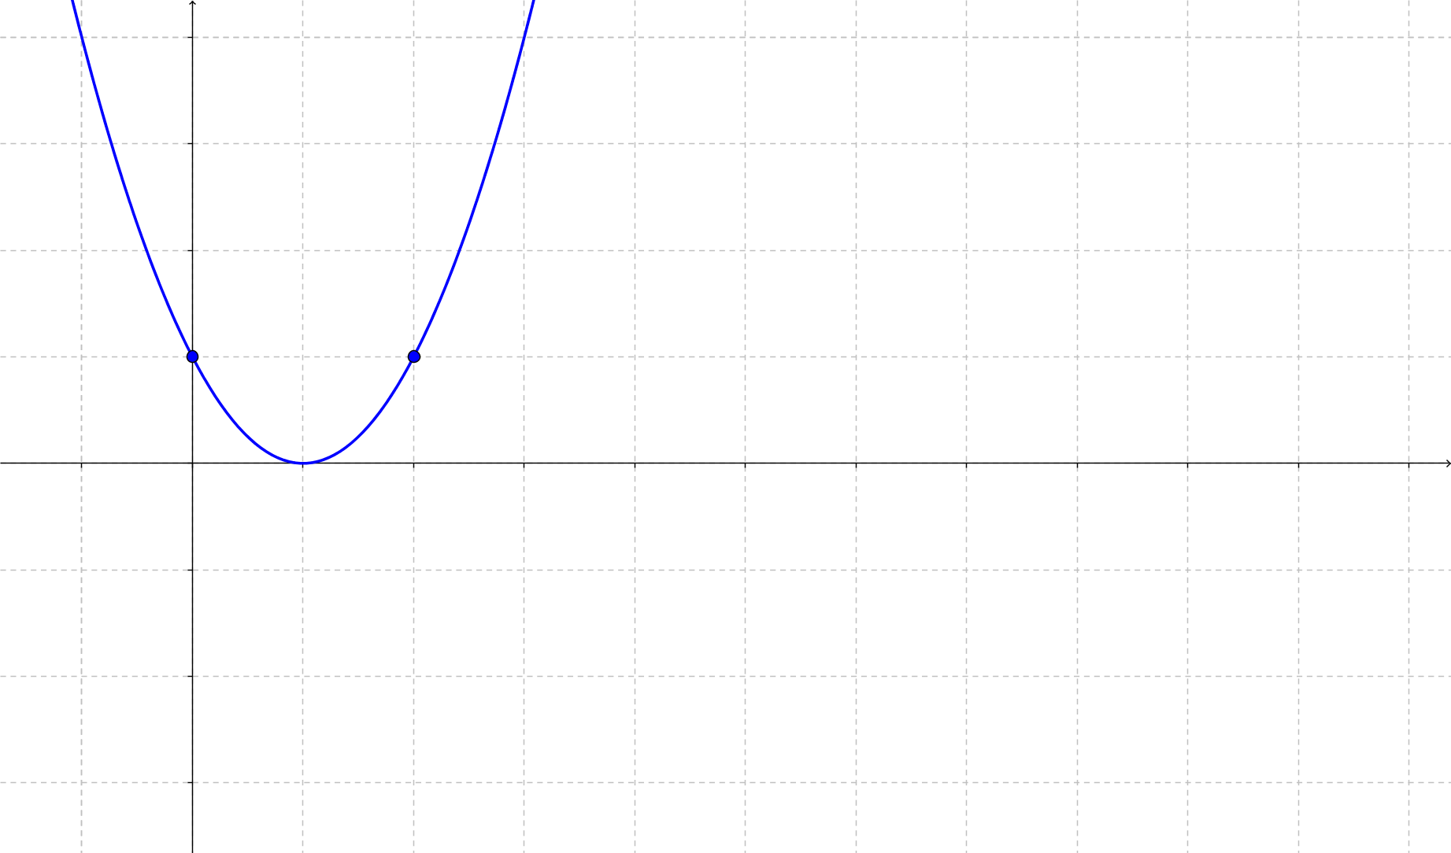
$$\left(0, 1\right)$$
$$\left(1, 1\right)$$
$$x$$
$$\left(5, 3\right)$$
$$x$$
$$\left(1, -1\right)$$

$\left(C\right)$ $\left(D\right)$
$$y$$
$$y$$
$$g\left(x\right)$$
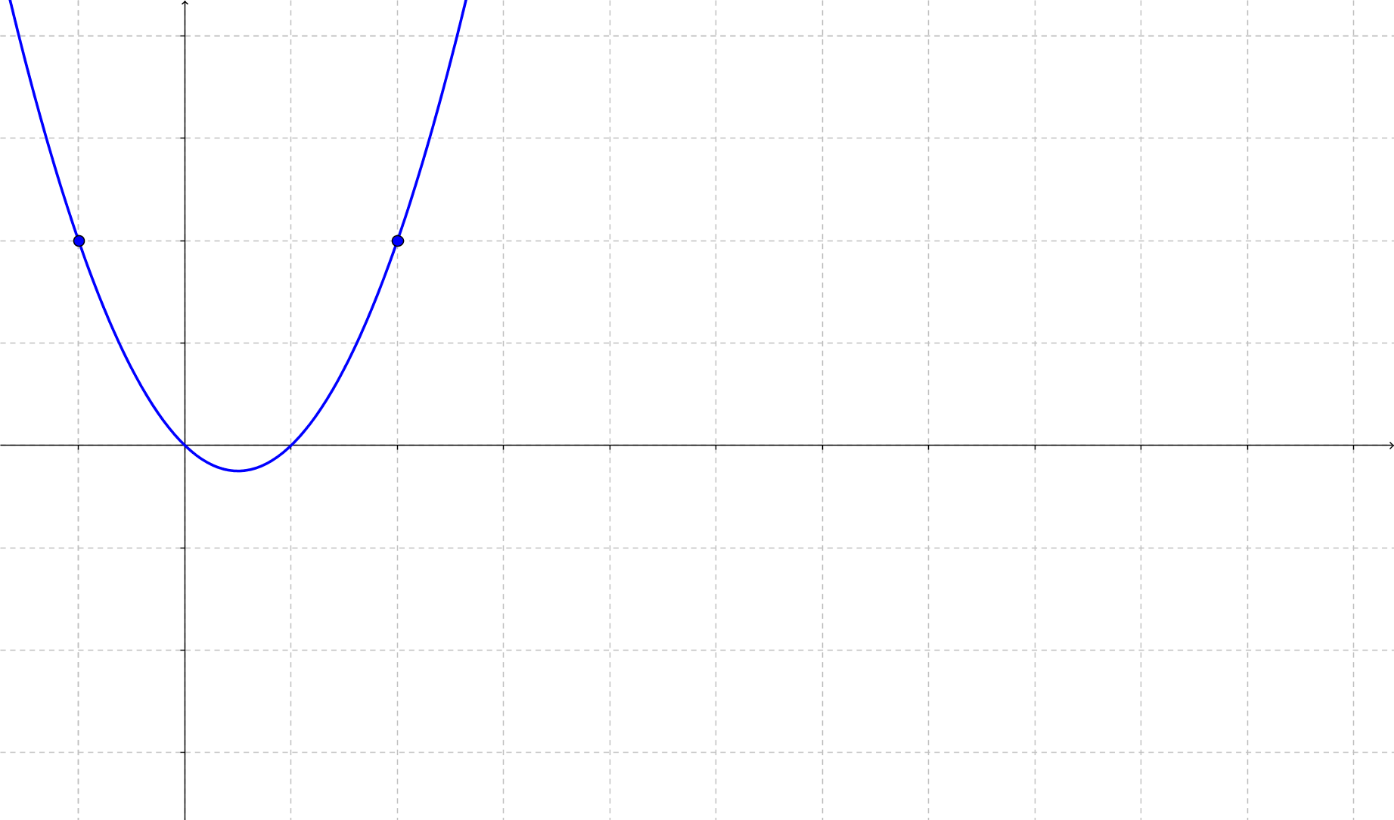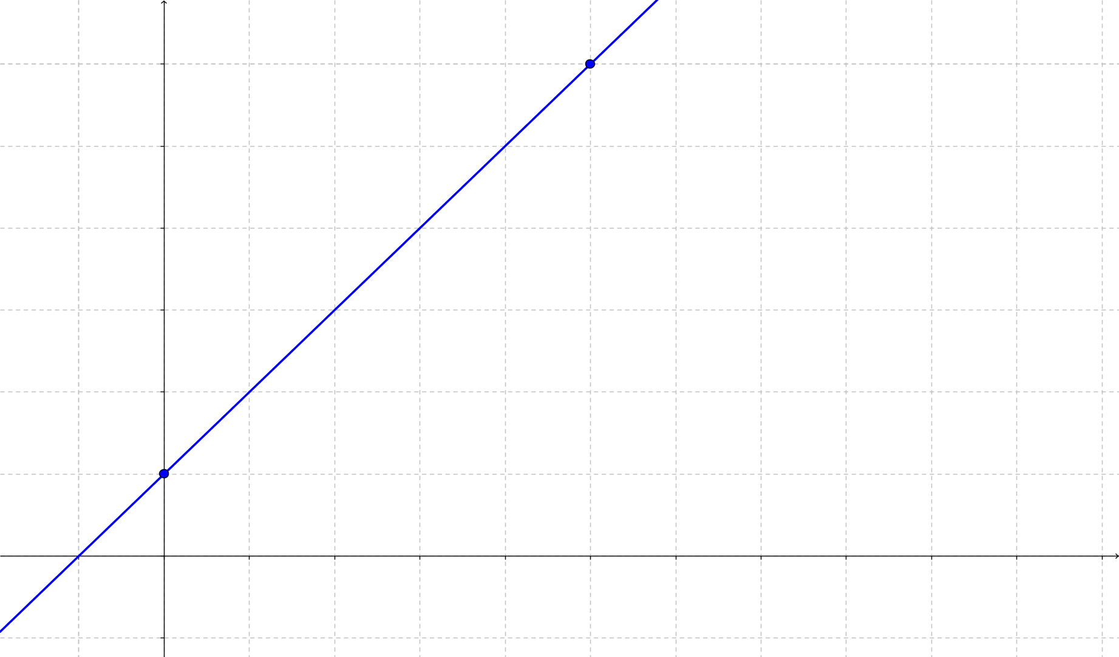
$$\left(5, 6\right)$$
$$g\left(x\right)$$
$$\left(0, 1\right)$$
$$x$$
$$\left(-2, 2\right)$$
$$\left(2, 2\right)$$
$$x$$

$$\left(E\right) none of the above$$

Solution:

(5) Wind resistance tends to slow down moving objects. Wind resistance varies jointly as an object's surface area $A$ and velocity $v$. If a car traveling at a speed of 40 $mph$ with a surface area of 37.8 $ft^{2}$ experiences a drag of 222 $N$ (Newtons), how fast must a car with 51 $ft^{2}$ of surface area travel in order to experience a drag force of 430 $N$?
$$\left(A\right) 25.8 mph \left(B\right) 46.5 mph \left(C\right) 57.4 mph \left(D\right) 62.8 mph \left(E\right) none of the above$$

Solution:

